The Cell Membrane

The cell membrane helps to balance the internal condition of the cell-maintain Homeostasis, while the cell exists in an aqueous medium.

1938-University of Toronto-Made “first” usable electron microscope-Could finally see that the membrane was a BILAYER of PHOSPHOLIPID molecules.

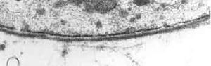

Functions:
- Protective barrier
- Controls what goes IN & OUT of the cell (selectively permeable) (proteins)
- Allows for cell recognition (carbohydrate chains)
- Signal reception and transduction (proteins)
- Provides anchoring sites for cytoskeleton (proteins)
- Provides a binding site for enzymes

Recall: phospholipids have a polar head and non-polar tail region.

Cell membrane is a PHOSPHOLIPID BILAYER.

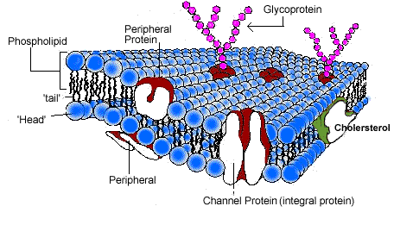

Small molecules and larger hydrophobic molecules pass through the membrane easily (e.g. O₂, CO₂, H₂O).
Ions, hydrophilic molecules and large molecules such as proteins do not. Materials that are soluble in lipids can pass through the cell membrane easily.

Cell membrane also called: FLUID MOSAIC MODEL (FMM)

FLUID: Individual phospholipids and proteins can move side-to-side within the layer, like it’s a liquid. If there is a puncture to the membrane, the phospholipids will quickly rearrange to seal the area.
What factors fluidity?
- Temperature: Inc Temp-bilayer becomes too fluid to act as a barrier
Dec Temp-bilayer changes to a gel-like state

- Presence of double bonds: increased double bonds, many “kinks”-less tightly packedincreases fluidity

- Length of FA tail: long FA increases intermolecular attractions reducing fluidity

- Presence of cholesterol: at room temp and above cholesterol inc intermolecular forces, holding it closer together decreasing fluidity. At low temps, cholesterol helps to keep the bilayer from changing into a solid gel-like state

MOSAIC: The pattern produced by the scattered protein molecules when the membrane is viewed from above.

