SBI3U/4U: Lab Report Format

Your formal lab reports will require all the parts listed below (unless otherwise stated by your teacher). Please follow the directions carefully to ensure that you receive full marks for all the labs that you complete. Grammar, spelling and sentence structure will also be evaluated on formal reports. ***Plagiarism will not be tolerated and will be given a mark of zero.

Title Page: include the following:
- Create a new title that tells the reader what the lab is investigating. Ensure that it is significantly different from the title that is given in your textbook or from another student in the class.
- NAME: Your full name (first and last)
- PARTNER(S) full NAMES, including their last name(s)
- TEACHERS NAME
- COURSE CODE: find this on your timetable
- DATE PERFORMED (Full date)
- DATE DUE: (Full date)
- Do not include any pictures or illustrations (this is not an art project)

All labs must be written in the present tense and may NOT include references to “I”, “me”, “you”, “he”, (except in the analysis section).

Purpose: a ONE sentence statement identifying why we are performing the experiment. Check textbook or lab sheet, many times there is an introduction and an overall question that may assist you with this. This must be different from all other class members!
e.g. To determine which fish food makes fish gain the most mass in two weeks.

Hypothesis: This is a tentative explanation that can be tested and will be in the form of an “If…then…because…” statement. The hypothesis should relate directly to the research question or the purpose. It should be specific and quantitative (if possible). It should express a possible relationship between the independent (manipulated) variable and the dependent (responding) variable. e.g. “If .....(manipulated variable)..... is done, then ..... (responding variable) ...... will occur ......because ..... (reasoning) ......”.

Note that your hypothesis does not need to be correct, i.e. your investigation might prove it incorrect (and that’s okay!)
e.g. IF a fish is given FISHCO food “A” for two weeks, THEN it will gain the most mass BECAUSE it contains the proper ratio of nutrients for fish growth.

Sometimes when you are designing your own experiment, it is important to think about the “Variables” involved.
Independent Variable (IV): manipulated variable (what variable will you change?)
Dependent Variable (DV): responding variable (is the result or change that occurs because of the manipulated variable (IV).
Controlled Variables: those other factors which must be held constant so that they do not affect the responding variables-usually there are many of these!
The CONTROL group: is when the independent variable either is eliminated or is set at a standard value.

For example, if you this is your experiment: “To determine which of the 3 NEW fish food flavours produced by “FISHCO” makes fish gain the most mass in two weeks”. Your experimental design might have you set up 4 identical fish bowls, with three goldfish in each. Each bowl would receive one of the new flavours and one would have the “original” flavor for the duration of the experiment (standard value).

Independent Variable: Fish food flavour (this is what is different between each bowl-you are manipulating it)
Dependent Variable: Mass of the fish at the end of the two week experiment (it is assumed that a starting mass was initially determined)
Controlled Variables: starting mass of each of the fish, number of fish/bowl, amount of food given daily, length of the experiment, temperature of bowl water, amount of light, etc.
Control Group: “original” flavour food

Remember-ALL variables are controlled (not changed), EXCEPT the manipulated variable, which is the factor that you, the experimenter, investigate or change in a systematic manner during the experiment.

Materials: List only what you have used, using proper terms.

Safety: Use the internet to search for the MSDS (Material Safety Data Sheet) for SPECIFIC chemical(s) that you will be using during the laboratory activity. Your teacher will tell you which chemical(s) to research for its SAFETY PRECAUTIONS (what the handler needs to keep themselves protected) and/or first aid measures. You MAY be asked to include a proper reference (can be located on the weebly “How to Reference in SBI3/4U” for each chemical (ask your teacher!). If you do need to include it, place the reference directly (and properly) at the end of the safety section.

Procedure: Unless otherwise stated this will be in the form of a NEAT flow chart (a rough flow chart can be used during the laboratory exercise) that simplifies the procedure. Flow charts will be checked before the student may begin the investigation. The purpose of this is to force you to work through the activity in your mind (and on paper) before you actually perform it and to make you aware of the safety precautions that you will have to follow during the investigation. Flow charts can include pictures or just words but should allow you to conduct the investigation without the textbook. DO NOT rewrite the steps in the book, DO NOT number your steps and add arrows in-between them! For example:

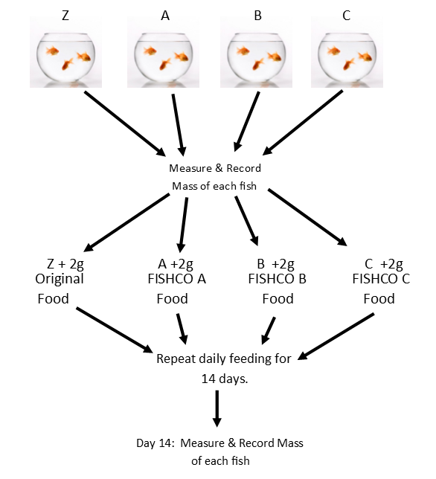
Observations:
Include only what you have observed- not what you predicted should have happened! If you include an observation table follow these rules; TABLE 1: Masses of Fish consuming Various Food Flavours for Two Weeks

Fish Food | Combined Fish Starting Mass (g) | Combined Fish Ending Mass (g)
FISHCO A | 13.1 | 17.6
FISHCO B | 14.8 | 16.7
FISHCO C | 12.7 | 20.7
Original | 12.9 | 15.9
**Title-must be relevant to the table contents!
**Use a pencil + ruler, or computer software
** Place units (if entire column is the SAME)
in the column heading ONLY
**If the table continues onto a second page,
repeat title with “continued” following it, and repeat column headings. Ensure this table could stand alone if the first
sheet goes missing.
Analysis Questions: These answers are to be written in FULL sentences (the reader must be able to understand what the question was asking by reading your answer only).

Conclusion: Refer back to the original purpose and hypothesis of the experiment to make a thorough conclusion. Refer to actual numbers (including units) to make concluding statements, and conclude only relevant information.
e.g. When fish consume various flavours of FISHCO food , over a two week period, there is evidence to support that Flavour C caused the fish to gain the most mass. Flavour C fish increased in mass by 8.0g while Flavour A…., and Flavour B…, while the Original Flavour food had fish change in mass by ….. Therefore from this experiment Flavour C fish gained the most mass over a two week period.

Avoid the word “PROVES”, one experiment proves nothing, multiple repeated experiment by multiple scientists might start to show a strong correlation.

**Plagiarism will not be tolerated-both parties may receive a ZERO**

