Dissection of Rattus norvegicus
OBJECTIVES:
- To name mammalian organ systems (digestive, circulatory & respiratory), and state the function of each
- To identify the organs related to these organ systems in a dissected rat
- To relate the structures of these organs to their functions

Introduction:

In this lab, you will be examining many characteristics of a rat’s anatomy. Dissections help researchers get a 3-dimensional picture of how the systems of a body work together. Now you’ll have the opportunity to see how the respiratory, digestive and circulatory system are arranged spatially.

The Classification of the Rat (Rattus norvegicus):

Kingdom: Animalia
Phylum: Chordata
Subphylum: Vertebrata
Class: Mammalia
Order: Rodentia
Family: Muridae
Genus: Rattus
Species: Rattus norvegicus
Note:
Dissection does not mean “to cut up.” Rather, it means “to expose for viewing.” Therefore, please follow the instructions outlined in this lab for proper dissection technique and never cut more than is absolutely necessary to expose an organ. Raise structures that you wish to cut with forceps so that you can see what lies underneath. Approach the dissection in a step-like manner. Do not discard any organs until all sections are completed.

Safety
Listen carefully to the safety precautions that your teacher explains to you. You will be required to wear safety goggles, a lab apron, and gloves for the duration of the activity. If you feel unwell, move to the desk area of the classroom if possible and inform the teacher. At the end of each period ensure you use the bleach-water spray on your entire work area (including sinks and taps), wipe the area, wipe with plain water and leave to air dry. Be very careful when you are cutting into the organism with the scissors to avoid cutting into any underlying organs. When in doubt, ask your teacher for assistance!
Materials:

- Preserved rat
- Dissecting pan
- Scissors
- Scalpel
- Forceps
- Probe
- T-Pins
- Twine/string

Anatomical Terms Used to Locate Organs or Incisions During This Dissection
Term | Meaning
Dorsal | Upper or back surface
Ventral | Under or belly surface
Lateral | Side
Anterior | Toward the front (head) end
Posterior | Toward the back end
Superficial | Near the surface
Proximal | Close to
Distal | Far from

Instructions:
Part One: External Anatomy

- Put on protective clothing and obtain a preserved fetal rat.

- Rinse your specimen in a large sink.

- Identify the external features of your specimen. Key terms are underlined.

The rat’s body is divided into six anatomical regions:
- Cranial region – head
- Cervical region – neck
- Pectoral region – area where front legs attach
- Thoracic region – chest area
- Abdomen – belly
- Pelvic region – area where the back legs attach

- Note the hairy coat that covers the rat and the sensory hairs (whiskers) located on the rat’s face, called vibrissae.

- The mouth has a large cleft in the upper lip which exposes large front incisors. Rats are gnawing mammals, and these incisors will continue to grow for as long as the rat lives.

- Note the eyes with the large pupil and the nictitating membrane found at the inside corner of the eye. This membrane can be drawn across the eye for protection. The eyelids are similar to those found in humans.

- The ears are composed of the external part, called the pinna, and the auditory meatus, the ear canal.

- Locate the teats on the ventral surface of the rat. Check a rat of another sex and determine whether both sexes have teats.

- Examine the tail. The tails of rats do not have hair. Other rodents, like gerbils, do.

- Locate the anus, which is ventral to the base of the tail.

Take a picture of the external anatomy of your rat.
- Determine whether your rat is male or female by looking near the tail for the male or female genital organs.
Male urogenital structures
Penis -
is hidden on the male rat beneath a fold
of skin (the foreskin or prepuce).
Scrotum
- is a pouch that contains the
testes

Figure 1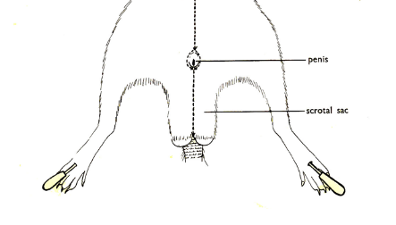
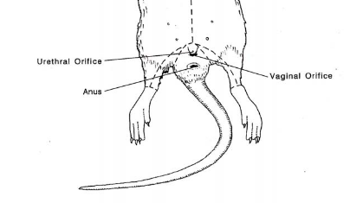
Female urogenital structures
Urethral orifice
- is the opening into the urethra (part of the urinary system).

Vaginal orifice

- is the opening into the vagina
(part of the reproductive system).

Take a picture of both sexes and their urogenital structures.

Part Two: The Digestive System

A: The Mouth

- Using a pair of dissection scissors, make a cut in the corner of the mouth, cutting towards the posterior of the specimen. Repeat on the other side.

- Pry the mouth open. Try to locate and identify the features of the oral cavity-teeth, tongue, hard & soft palate, epiglottis (may not see yet, if unable to come back to it once you’ve opened up the thoracic cavity and neck region).

Analyze & Interpret
- Explain how the appearance of the following structures relates to their function as part of the digestive system. Give as much detail as possible, including size, texture, external structure, and internal structure.
  - The teeth
  - The tongue
  - The epiglottis
  - Hard & soft palate
- What differences can you see between the pig’s mouth structures and your own? Suggest a reason for these differences.

B. Exposing the Abdominal Organs

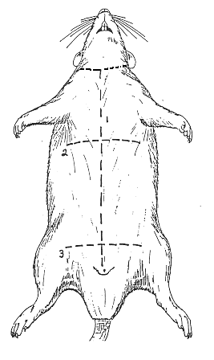
- Place the rat in the dissecting tray with its ventral surface uppermost. Spread out the limbs. Tie a piece of string to one of the forelimbs near the ankle. Pass the string under the tray and securely tie the other forelimb. Repeat the process with the hind limbs.

Figure 2
4

- Using your forceps, gently pinch the skin at the “star” on Figure 2. Use scissors to cut through the abdominal wall of the rat at the star and cut down the length of its body until close to the end of its body (see Figure 2).

- Cut slowly and carefully; do not cut too deeply to prevent damaging the underlying structures. Keep the tip of your dissection tool pointed upwards.

- Complete cuts #2 and #3 on Figure 2.

- Once the incisions have been made, pin both skin flaps to the side of the rat using the T-pins.

- Use figure 3 to locate and identify the organs of the abdominal cavity.

C. Examining the Abdominal Organs

Take a picture of the abdominal organs.

- Locate the liver, the largest organ of the abdominal cavity. Describe its appearance in your own words. Note its different lobes. The rat DOES NOT have a gall bladder-if it did it would be located underneath the right side of its liver.

- Locate and describe the esophagus. Note how it passes through the diaphragm just before it enters the stomach. Figure 3
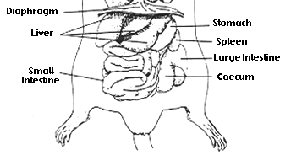
- Locate and describe the stomach. Carefully cut open the stomach and describe the inner surface.

- Locate and describe the spleen.

- Locate and describe the pancreas, situated below the stomach, between the stomach and the small intestine. The greater omentum is the membranous curtain of tissue that hangs from the stomach and contains lymph nodes, blood vessels and fat. Find the pancreas by looking for a thin, almost membrane looking structure that has the consistency of cottage cheese.

- Locate and describe the small intestine. See if you can identify the separate portions of the duodenum, ileum, and jejunum. You will be removing this later and attempting to “untangle” it into one long tube.

- Locate and describe the cecum. In the rat this is a large sac in the lower third of the abdominal cavity, it is a dead-end pouch (some people mistake it for the stomach!)

- Locate and describe the large intestine.

- Towards the end of the large intestine is the rectum. Note where the tract terminates at the anus.

- CUT the esophagus as close to the bottom of the diaphragm (top of abdominal cavity) as possible. Make a second cut as close as you can to the end of the digestive tract near the anus. Carefully remove the entire digestive tract, in one piece, from your specimen. Place the digestive tract in your dissection tray OR on a paper towel on your lab bench.

- Carefully cut away the connective tissue around the digestive tract. Unravel the WITHOUT breaking it. Identify the different sections of the digestive tract. Measure each section of the digestive tract.

Take a picture of the unraveled digestive tract.

Analyze and Interpret

- Explain how the appearance of the following structures relates to their function as part of the digestive system. Give as much detail as possible, including size, texture, external structure, and internal structure.
  - Liver
  - Pancreas
  - Esophagus
  - Stomach
  - Small intestine
  - Large intestine

- Using your own pictures of the abdominal organs, trace the path of food from the mouth to the rectum. Identify the major steps in the digestive process that take place along the way.

Part 3: The Circulatory System

The general structure of the circulatory system of the rat is almost identical to that of humans. Pulmonary circulation carries blood through the lungs for oxygenation and then back to the heart. Systematic circulation moves oxygenated blood through the body after it has left the heart.

- Exposing the Organs of the Thoracic Cavity
- Locate the base of the sternum (breast bone), which is in the centre of the chest. The ribs are attached to the sternum. Use this as the starting point for your incision. With forceps, pinch the skin of the abdomen along the midventral line and draw it slightly away from the animal. With your scissors, make an incision in the skin-the incision should be just large enough to pass the point of your scissors through. Move towards the head into the rats neck region-base of throat. See Figure 2. Be careful not to damage the underlying body wall as you cut. Remember to keep the tips of your scissors pointing up, not down, to avoid damaging the internal organs.

- Next make two cuts from the midventral line (see Figure 2, dotted line #4). Carefully lift the skin and pin it to the sides it to your tray using T-pins. The T-pins should point away from the specimen so they will not interfere with your work.

- Using your scissors, cut the ribs along the sternum and pry them apart to revel the organs of the thoracic cavity.

- Using forceps or a dissecting probe, remove the connective tissues and membranes that surround the lungs and heart.

- Use Figure 3 to identify the internal organs of the thoracic cavity.

Take a picture of the opened thoracic cavity.

- Examining the Organs of the Circulatory System Figure 4
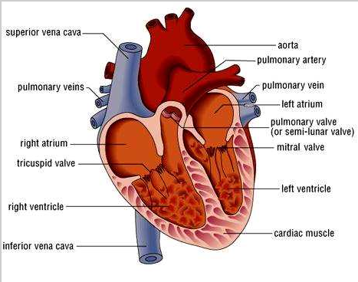
- Locate and describe the heart

- Using Figure 4 for reference, identify and compare the sizes of the following major blood vessels.
  - Aorta
  - Superior vena cava
  - Pulmonary artery
  - Pulmonary vein
  - Inferior vena cava

Take a picture showing the location of the circulatory system.

- Carefully cut through the blood vessels a short distance from the heart. Cut the heart in half lengthwise (same as during your sheep heart dissection), your cut should expose all four chambers.

- Use Figure 4 to try and identify the internal features of the heart. Try to locate and identify the heart valves at the opening to the blood vessel.

- Compare the structure of the different chambers of the heart.
Take a picture showing the chambers of the heart.

Analyze and Interpret
- Explain how the appearance of the following structures relates to their function as part of the circulatory system. Give as much detail as possible, including size, texture, external structure, and internal structure.
  - Right atrium
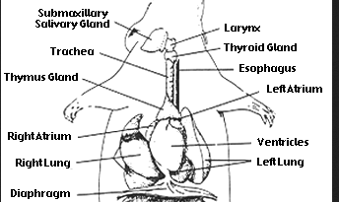
  - left atrium
  - Right ventricle
  - Left ventricle
  - Arteries
  - Veins
  - Heart valves

Part 4: The Respiratory System
Examining the Respiratory Organs Figure 5
- Using Figure 4 for reference, identify the major organs of the respiratory system.

- Note the difference in structure between the right and left lung. In your own words, describe the structure and texture of the lungs.

- Locate and describe the pleural membranes encasing each lung

- Using a probe, move aside the layers of muscle to work deeper into the neck. If necessary, carefully cut the muscle tissue. Locate the larynx, trachea, and esophagus. Describe the difference in structure between the trachea and esophagus.

- Examine the rib cage and try to identify the external and internal intercostal muscles.

- Open the mouth and describe the relationship between the glottis, esophagus, and pharynx.

- Trace the passage of the trachea through the throat. Try to identify the two branches of the bronchi.

- Using a small syringe, push a small amount of air into the trachea. Note the inflation of the lungs.
Take a picture showing the location of the circulatory system.

Analyze and Interpret
- Explain how the appearance of the following structures relates to their function as part of the respiratory system. Give as much detail as possible, including size, texture, external structure, and internal structure.
  - Trachea
  - Right lung
  - Left lung
  - Pleural membrane
  - Larynx
  - Glottis
  - Diaphragm
  - Rib cage

- Using your own picture, trace the path of air from the mouth to the lungs.

CONGRATULATIONS you have completed your dissection! Clean up your specimen and dissection area according to the instructions from your teacher.

