Hormonal Regulation of Growth, Development, and Metabolism (9.2)

Recall: the pituitary gland is controlled by the hypothalamus via releasing hormones and it secretes tropic hormones.

Two separate glands make up the Pituitary Gland:
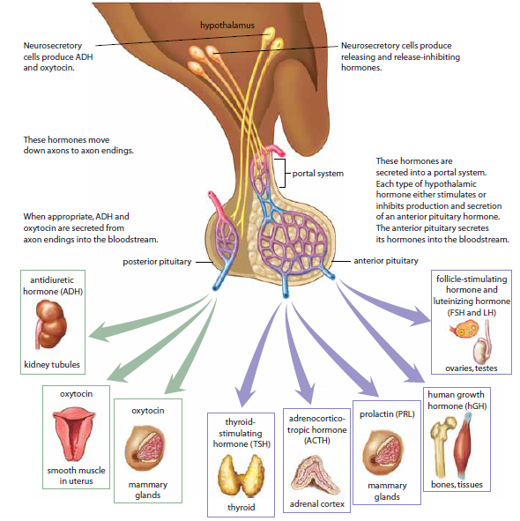
- Posterior Pituitary: actually part of the nervous system and its job is to store and release the hormones ADH & oxytocin which are produced in the hypothalamus and moved to the post. Pit by neurons.
- Anterior Pituitary: Produces and releases 6 major Hormones;
    - Thyroid-stimulating hormone (TSH)targets thyroid gland
    - Adrenocorticotropic hormone (ACTH) targets adrenal cortex
    - Prolactin (PRL) targets mammary glands
    - Human growth hormone (hGH) targets most cells
    - Follicle-stimulating hormone (FSH) targets testes or ovaries
    - Luteinizing hormone (LH) targets testes or ovaries
  - The hypothalamus sends a message to the anterior pituitary to either stimulate or inhibit the release of hormones from this gland into the bloodstream

Human Growth Hormone (hGH):

hGH affects almost every body tissue. The majority of its effects are tropic.

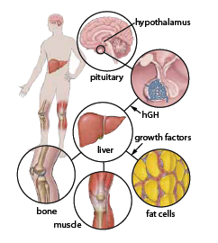
P398 Fig. 9.8:
-hHG stimulates the liver to secrete growth factors which can increase protein synthesis, cell division and growth (especially of cartilage, bone & muscle) or cause the metabolic breakdown and release of fats stored in adipose tissue.
Conditions:
- Gigantism: too much hGH secreted during childhood
- Dwarfism: insufficient hGH production during childhood
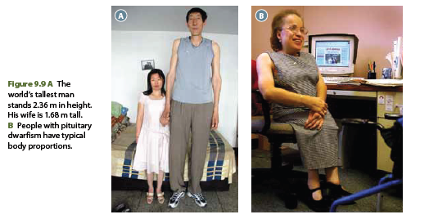
- Acromegaly: overproduction of hGH during adulthood (when skeletal growth is completed) causes bones and soft tissues of the body to widen + p399 Fig 9.10

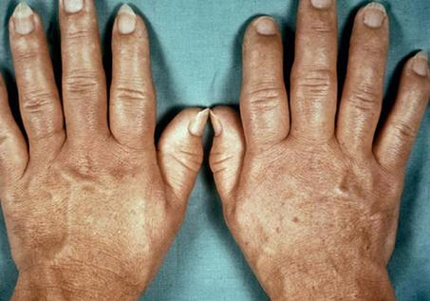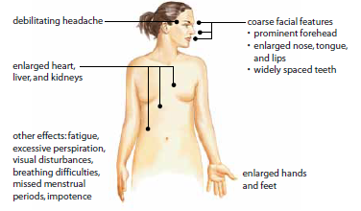

Thyroid Gland: A Metabolic Thermostat:

The thyroid gland is located below the larynx and on top of the trachea. It secrets immature thyroid hormones into the spaces between the cells of the thyroid gland.
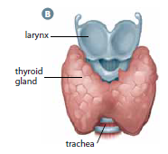
For example Thyroxine (T₄), once functional, will be released into the bloodstream, where it increases the rate at which the body metabolizes fats, proteins, and carbohydrates for energy. T₄ stimulates the cells of the heart, skeletal muscles, liver and kidneys to increase the rate of cellular respiration.

Conditions:
- Hypothyroidism: A failure of the thyroid to develop during childhood results in cretinism which results in low levels of T₄ to be produced. Individuals are stocky and shorter than average, will have mental developmental delays if not treated early on in life. Adults with this condition will feel tired, have a slow pulse rate, and slow metabolism.
- Hyperthyroidism: overproduction of T₄ causing anxiety, insomnia, heat intolerance, irregular heartbeat and weight loss. Graves’ disease (severe state of hyperthyroidism) resulting in the immune system attacking the thyroid.

Control of T₄ secretion is by negative feedback. TSH is released by ant. pit., which causes the thyroid gland to secrete T₄. If T₄ levels get too high, it signals the hypothalamus and ant. pit. to decrease secretion of TSH, thereby decreasing T₄ levels.
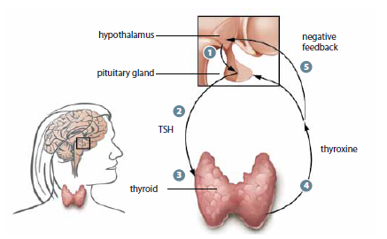

Iodine is required to make thyroid hormones. If I₂ levels are low, T₄ cannot be made and no message sent to ant. pit. to stop TSH secretion. Enlargement of the thyroid gland results in Goitre which is obvious due to visible swelling in the neck and difficulty in breathing and/or swallowing and coughing.

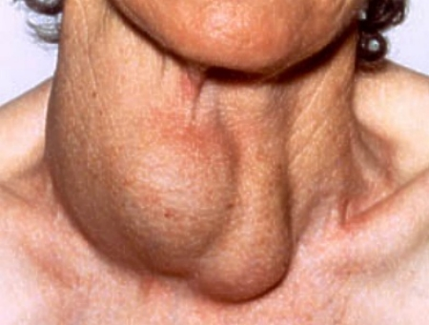

Thyroid Gland & Calcitonin: include p402 –what happens when Calcium levels get too high in the blood?

Parathyroid Glands:

Parathyroid Glands are 4 small glands attached to the thyroid gland and regulate the levels of calcium in the blood.

-If Ca²⁺ levels are high, calcitonin is released and stimulates the uptake of calcium into bones, thereby lowering the Ca²⁺ levels in the blood.

-If Ca²⁺ levels are low in the blood, parathyroid hormone (PTH) is produced and it stimulates;
- bone cells to break down bone material and secrete Ca²⁺ into the blood
- the kidneys to reabsorb Ca²⁺ from the urine, activating vitamin D in the process
- Activated Vit. D stimulates the absorption of Ca²⁺ from food in the intestines
all 3 increase the concentration of Ca²⁺ in the blood back to normal levels.

P402 Fig. 9.13-Negative feedback

HMK:
P403 #2-7,10,11

